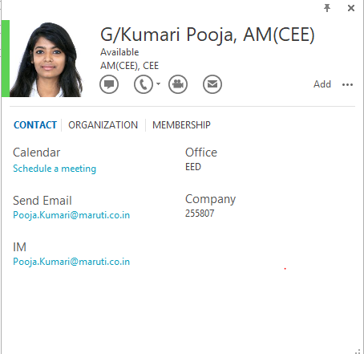**POOJA KUMARI**

**Email:** [poojakumard@outlook.com](mailto:poojakumard@outlook.com)

**Phone: +** 91-9871065457

**Career Intention:**

Automotive design, development & procurement manager seeking career opportunity in strategic sourcing & procurement in an organisation which offers opportunities to learn, serve & grow.

**Skills**

Over 7 years of experience in procurement of heavy machines and equipment in the field of Automotive Manufacturing.

* Good experience in tendering projects, vendor scrutinization, finalization and identifying new suppliers based on production requirements
* Co-ordinating with Suppliers for RFQ of required parts and ensuring proper conclusion of RFQ in time.
* Supplier questionnaire documentation and NDA sign off with new suppliers.
* Hands on experience in 2D and 3D part designing software (**UG-NX 9&11, AUTO-CAD** )
* Knowledge of Procurement managements software (**3D EXPERIENCE ENOVIA & SAP ARIBA**)
* Implementation for all design concerns, related to Cylinder Head dies.
* Localized vendor development for cost reduction
* Good Negotiation Skill for **Procurement of machineries & Automotive parts.**
* An effective Communicator with excellent Problem Solving, Supplier management, Interpersonal and Presentation skills.
* Problem solving through Root Cause Analysis, Countermeasure Identification
* Concern resolution based on Time, Quality, Cost, Delivery and Performance targets.

**Core Competencies**

**Software Known:** 3D EXPERIANCE ENOVIA, SAP ARIBA, UG-NX 9&11, AUTOCAD, MAGMASOFT, DATAPAQ Insight Furnace, GOM Inspect.

**Problem Solving Tools Known:** Quality control tools like Fault Tree Analysis, DFMEA, TQM, QC Story, 7 QC tools, Why-Why Analysis, 5S, Fault Tree Analysis (FTA), Fish Bone Diagram, etc.

**Professional Experience**

***Maruti Suzuki India Limited (Assistant Manager*): Nov 2014 to Present**

**Projects Delivered:**

**1. Cylinder Head** **Manufacturing setup of Maruti Suzuki 1.5 L Petrol Engines *(K15B & K15C)*:**

**2. Cylinder Head Manufacturing setup of Maruti Suzuki 1.2 L Petrol Engine *(G12B)***

**3. Cylinder Head Manufacturing setup of Maruti Suzuki 1.0 L Petrol Engine *(K10B & K10C)***

**Work Description: (Procurement)**

* Design of Cylinder Head Main Dies & Core Dies, Procurement of various equipment for engine line expansion.
* Process purchase order and requisitions for product
* Communicate with prospective vendors to determine terms and availability
* Prepare reports for costs and market condition
* Analyzed customer needs and accordingly developed procurement requirement
* Build competitive bidding environment with broad range of suppliers
* Evaluated supplier’s bids for best match
* Readied purchasing files, price list and reports
* Negotiation with vendors & suppliers
* Purchased the highest quality product for the lowest possible price

**Work Description: (Others)**

* Cost reduction activities.
* OEE Improvement
* ISO 140001 certification preparation.
* OHSAS certification Preparation
* Process standard preparation
* Procurement of equipment for new line setup.

**Achievements:**

* Got promoted from ER (Engineer) to AM (Assit. Manager) with a double promotion because of good performance.
* Awarded certificate for best group performance in Quality improvement project 2017
* Won silver medal in Robotics competition organized by IGNITE 2015

**Certifications:**

* Certified Internal Auditor of ISO 14001:2015
* Certification course in Die casting technology & Die design by ALUCAST & NADCA (International Associations of casting engineering)
* NCC Cadet with B & C certification

**Education credentials**

Mechanical Engineering from AMIE (Associate member of the institution of engineers) 2019 **7.67** CGPA

Diploma,Mechanical Engineering from Govt. Polytechnic College, Jodhpur 2014 **7.40** CGPA

10th from Army Public school, Jodhpur 2011 **8.00** CGPA

**Additional Information**

**Date of Birth:** 22.08.1995

**Languages Known:** English (R/W/S/L), Hindi (R/W/L)

**Place**: Gurgaon